# Site Description

The purpose of this document is to describe the **templeinnsuites.org** website, its purpose and intended audience, scenarios, personas, target audience and content. Also, to have an idea about the design, colors and structure of the site. It is to be used as a planning and elaboration tool for the personal site to be developed this semester as part of the WDD 230 course.

# Site Name

This website will be called **templeinnsuites.org.** Focused in what the hotel is and serve for.

# Purpose Statement

**The Temple Inn & Suites** Website is designed with the objective of providing a specialized service for people who, not only serve in the temple, but others who participate in other sacred events, such as sealings, weddings, receptions, and youth temple trips. The website reflects the Church culture and is designed to support a temple oriented theme, as well as the concept of heavenly comfort and accessibility.

# Target Audience

The target audience of templeinnsuites.com is described below:

* **Who:** Members of the Church of Jesus Christ of Latter-day Stains and their non-member families.
* **Age:** 11 and more.
* **Technology:** This website will be accessed by many different type of devices, with technology of 3G, 4G, etc. And probably will be access by mobile devices more than personal computers.
* **Motivation:** Our motivation is that we know that the services that we offered are very necessary to all people that wants to serve in the temple, they can have access to all our beautiful facilities and it can be reserved for convenience.

# Personas

# **Occupation:** Sales Executive **Demographics and Education:** 28 years old. Jhon with Bachelor’s degree in Business Management and serving like Young Men President. **Social:** He loves spent time playing soccer and video games, but also, discovering new activities to share with his young men. **Goals:** He has the goal to assist to the temple with all the young men and serve doing proxy baptisms. **Quote:** “Be strong and of a good courage, fear not, nor be afraid of them: for the Lord thy God, he it is that doth go with thee; he will not fail thee, nor forsake thee”.A person in a suit Description automatically generated with medium confidence

**Occupation:** College Teacher **Demographics and Education:** 45 years old. She has a bachelor's degree in Education, she has 3 kids, and lost her husband a few years ago, she is recent convert.  
**Social:** She loves to spent time with her family, read the book of mormon and learn more about the temple work and the eternal families. **Goals:** She wants to be sealled to her husband and kids.  
**Quote:** “The most important of the Lord’s work you will ever do will be within the walls of your own homes”

# Scenarios

1. Can I go with my little kids?
2. Who can help me to take care of my little kids when I'm inside the temple?
3. How long can I be hosted?
4. What Do I need to do to reserve a room?
5. What Services “The Temple Inn & Suites” offered?
6. What services includes?

# Content List

**Scenario 1. Can I go with my little kids?**

The Temple Inn & Suites is a familiar place where you can came with all the members of your family and use of the services of our hotel.

**Scenario 2. Who can help me to take care of my little kids when I'm inside the temple?**

Even when we don't have a personal to take care of your childrens like part of the free services we have a playroom and low-cost, short-term babysitting services for the children of patrons

**Scenario 3. How long can I be hosted?**

You can be hosted all the time that you need to participate the blessings of the holy temple.

**Scenario 4. What Do I need to do to reserve a room?**

You just need to contact us with the details of your visit, like number of people, date of your visit, time that you need to be here, etc.

**Scenario 5. What Services “The Temple Inn & Suites” offered?**

**Specialized Services**

* Free access to changing rooms and bathroom facilities for temple patrons who have traveled far and need to change to and from church clothes
* A playroom and low-cost, short-term babysitting services for the children of patrons
* Long-term stay accommodations in kitchenette suites for full-time temple missionaries
* Temple history themed reception and sitting area
* A wedding reception hall that can be easily customized with a simple catering menu and kitchen access for food preparation and serving
* A family search center that supports family search and ordinance work
* and some other free amenities.

**Scenario 6. What services includes?**

**Free Amenities**

* Breakfast
* Exercise/workout room
* Indoor pool
* WiFi high-speed internet access and smart TVs
* Parking
* Temple shuttle
* Family history consultation and family ordinance card service

# Site Map

This section describes the basic structure of the **templeinnsuites.org** website.

Figure 1 – **templeinnsuites.org** Site Map, demonstrating the structure of the site.

# Style Guide

This section describes the visual and aesthetic plan for the templeinnsuites.org web site.

**Color Scheme**

Describes the background, text, links, accent(s), highlights, and logos of the templeinnsuites.org web.

**Primary color:**

Figure 2 - Color scheme for **templeinnsuites.org.**

An example for visualization purposes only of how these colors can be applied in the site, can be seen below:

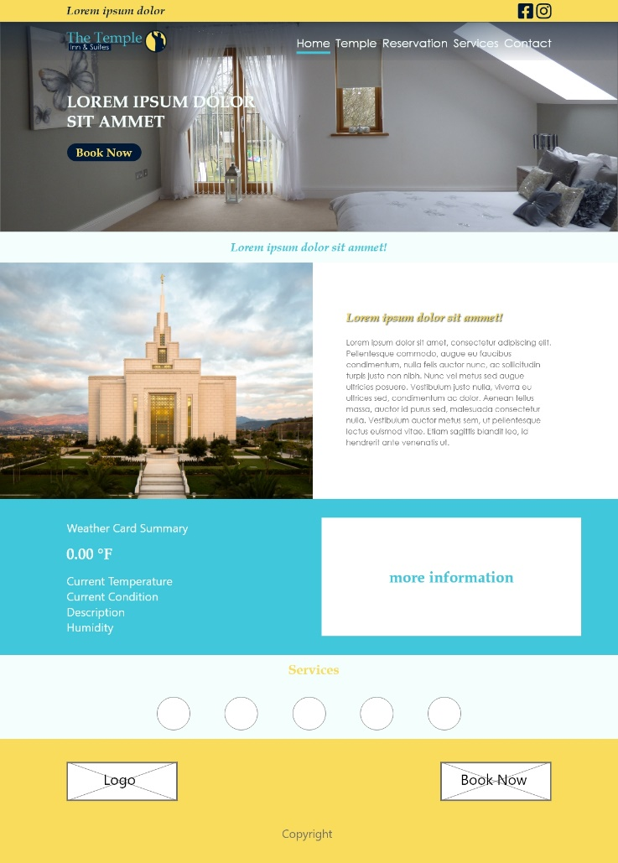

Figure 3 - - Example page, for color scheme visualization.

# Typography

Describes the fonts, font sizes, styles, and line height used in the **templeinnsuites.org** web site.

Table shows user the color, size, and font used in each of the areas of the page template.

|  |  |  |
| --- | --- | --- |
| Object/Item | Font Size | Color |
| Default Paragraph Text | Century Gothic  Weight: Normal 16px  Style: Normal | #696969 |
| Heading Level 2 (h2) | Century Book Antiqua  Weight: Bold 34px  Style: Italic | #F9DC5C |
| Heading Level 3 (h3) | Century Book Antiqua  Weight: Bold 28px  Style: Italic | #F9DC5C |
| Heading Level 4 (h4) | Century Book Antiqua  Weight: Bold 22px  Style: Italic | #F9DC5C |

# Navigation

Navigation will sit near the top of the page, between the header and the main elements. It will have the following characteristics:

* Selected Item: It will be Mint cream #F4FFFD for the text and an underline in Sky Blue #41C7DC.
* Unselected Item: Reversed color scheme and Mint cream #F4FFFD for the text.
* Dropdown navigation menu will will Oxford Blue #011936 background with #41C7DC text color and when is hover the background will be Naples yellow #F9DC5C and Mint Cream #F4FFFD for text.

See example below:



# Responsiveness

This section contains examples describing the layout of the website for the various formats supported.

**Desktop and Laptop**

Figure 5 - Desktop/Laptop Layout

**Tablet (Portrait)**

Figure 7 - Portrait (landscape)

**Smartphone**

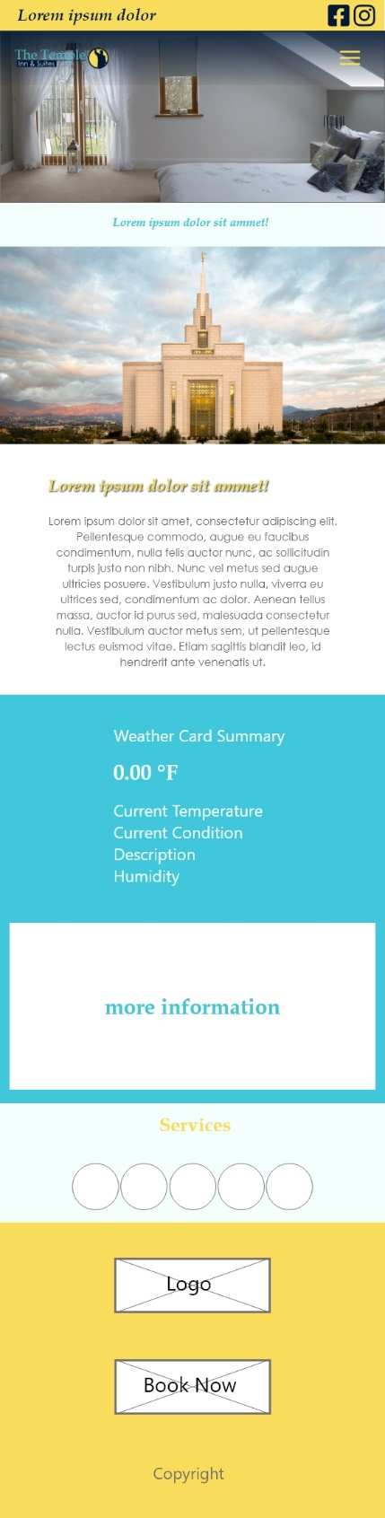Figure 8 - Smartphone layouts